# The Procedure

## Creating a Robot Station

Initially we start with an empty robot station in RobotStudio, where we are given the option to add an existing ABB robot system. For our particular cell, we are using the IRB2400.

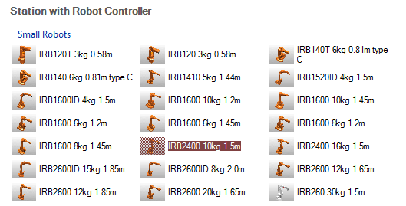

Figure 1: Selecting the Robot Controller for our Station.

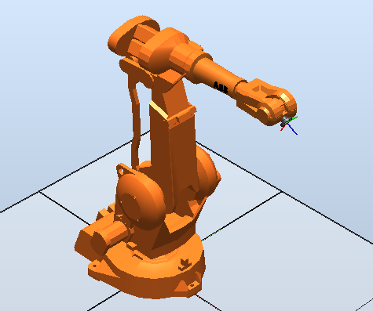

Figure 2: Station with the imported IRB2400

Now that we have imported the robot, we can now work on importing the other components of the cell, such as the table and dispensers. In order to do this we have been given the technical drawings of all the needed components, including their dimensions which enable us to model each part in modelling software such as SolidWorks or CATIA. Once each model has been constructed and checked for compliance with the given dimensions, it is exported as a geometry file such as a .wrl or .stl file, which can be parsed by RobotStudio and used as a part in our station. Because we want our components to eventually have their behaviours controlled by signals and properties, we add the models as components of their own Smart Components.

Once the component has been imported into the station, its position is set in compliance to the given cell dimensions, as to create a complete imitation of the real robot cell that is present in L220.

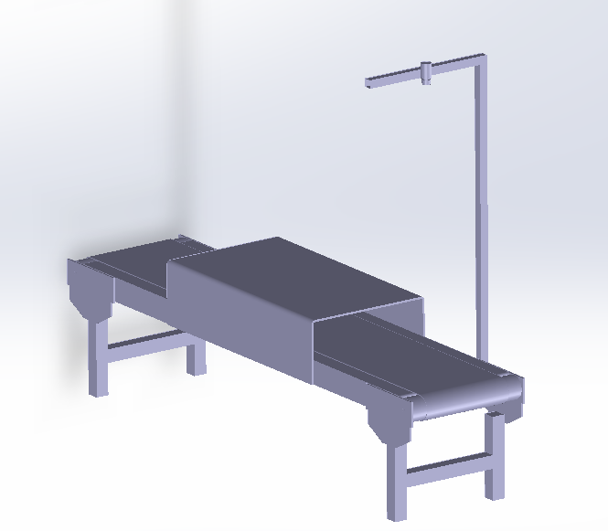 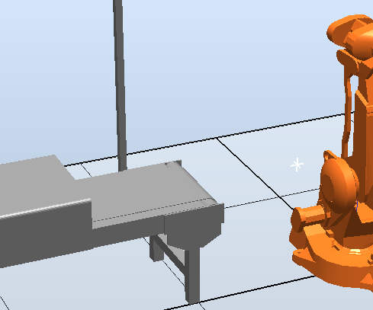

Figure 3: A finished model of the conveyer constructed in SolidWorks (left), which was then imported into the existing Robot Station (right)

This process is repeated until all components are present in the Robot Station. Once this has been achieved, and the configuration of the robot cell complies with the provided cell dimensions, it is time to incorporate events.

## Robot Tasks

“Teaching” the robot how to perform desired tasks is greatly simplified in RobotStudio and can be achieved in a number of ways. The first step is to set a series of robot targets and paths which are needed for the robot to carry out specific tasks in specific ways.